DATA STRUCTURES AND ALGORITHMS

NAME: Lakshmi Prabha M M
ROLL NO : 25BAD049
CLASS: A-10 slot

TASK -1: IMPLEMENTATION OF LIST USING ARRAY ADT
AIM:
To implement a list using array ADT and perform basic operations such as insert , delete ,update and display.
PSEUDO CODE :
START
Read n
Read n elements into array
Repeat
Display Menu
1.Insert
2.Delete
3.Update
4.Display
5.Exit
Read choice
If choice = 1
Read position and element
Shift elements to right
Insert element
Increment n
Else if choice = 2
Read position
Shift elements to left
Decrement n
Else if choice = 3
Read position and new value
Replace element
Else if choice = 4
Display all elements
Until choice = 5
STOP
SOURCE CODE :
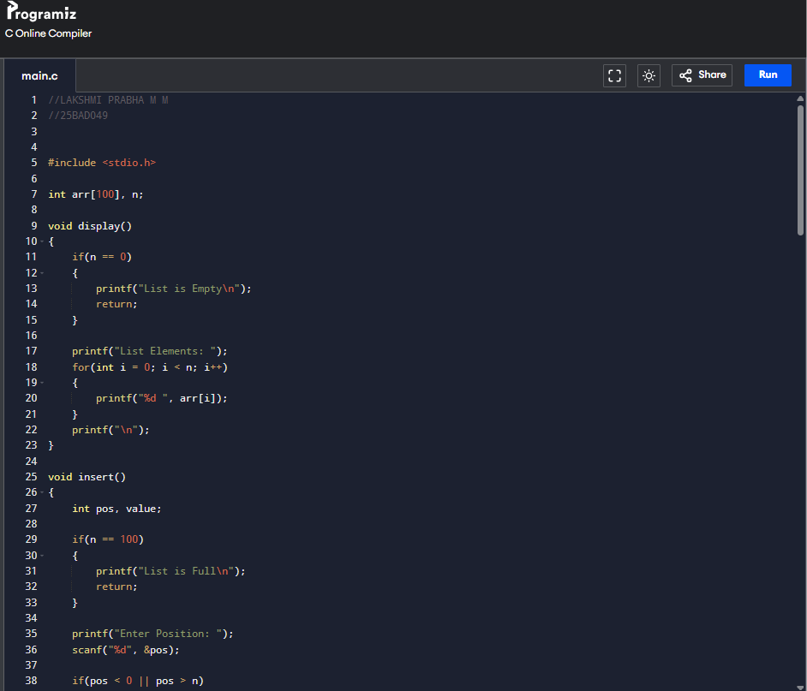
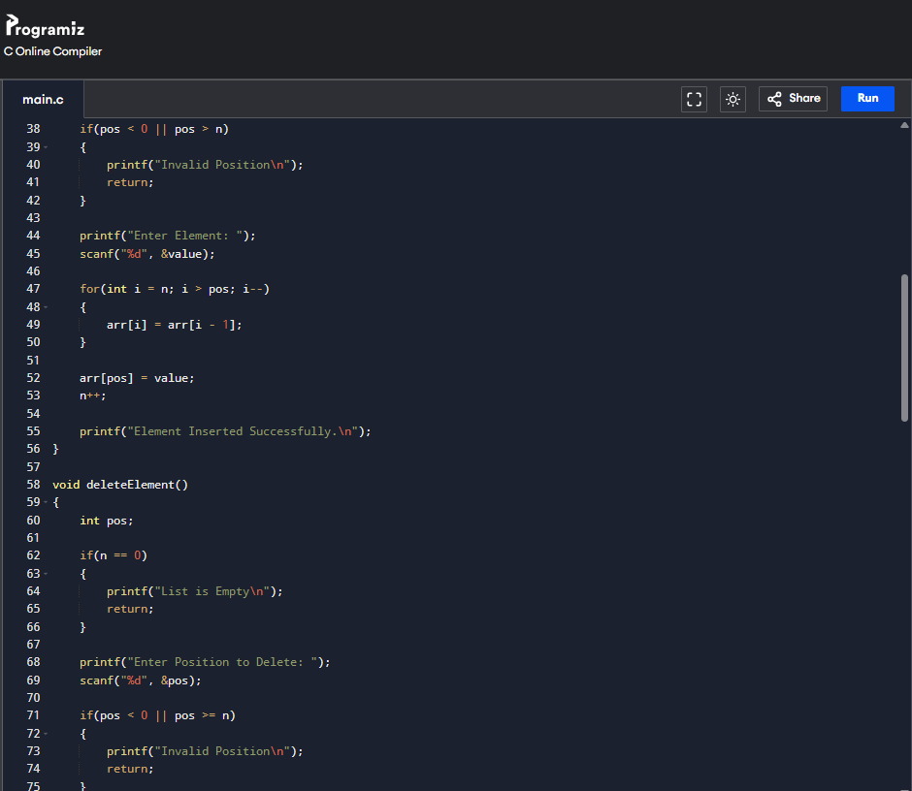

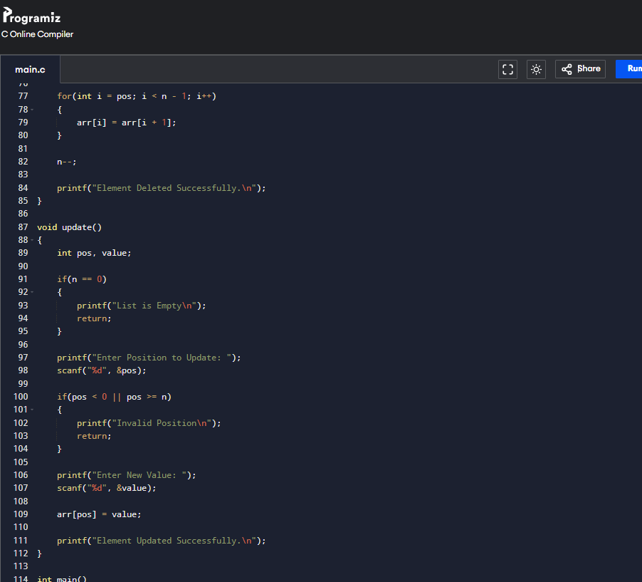
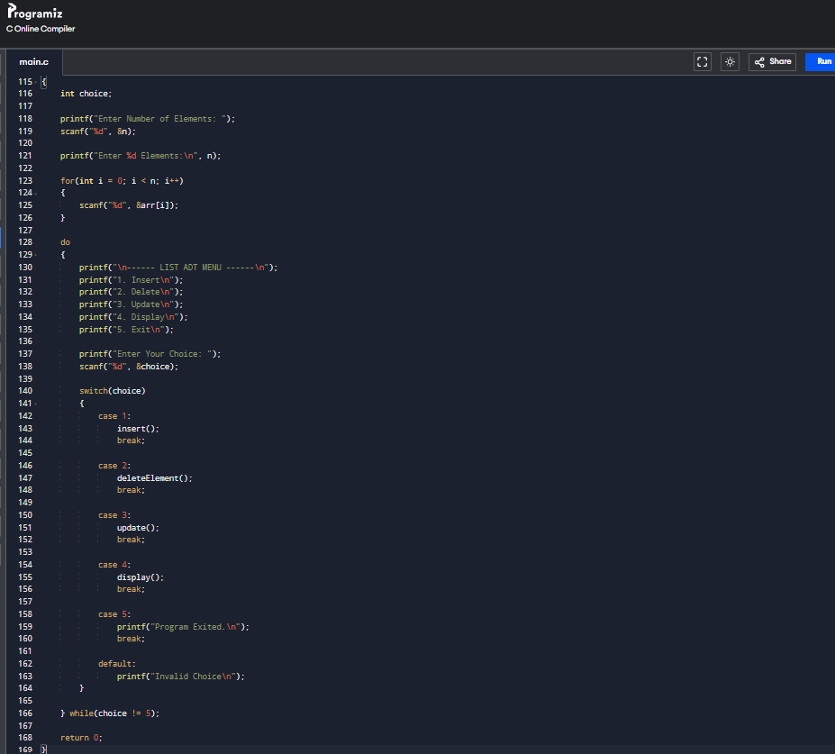
OUTPUT :
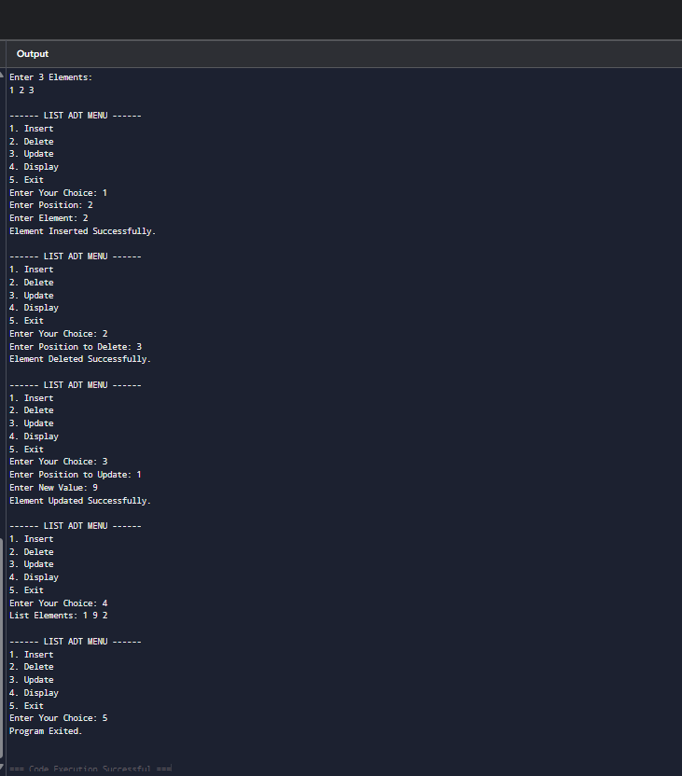
TASK -2 : LINEAR SEARCH USING ADT
AIM:
To implement the Linear Search algorithm using an array ADT to search for a given element in the array.

PSEUDO CODE :

START
Read n
For i = 0 to n-1
Read arr[i]
End For
Read key
For i = 0 to n-1
If arr[i] == key Then
Print "Element Found at Position", i+1
STOP
End If
End For
Print "Element Not Found"
STOP

SOURCE CODE:
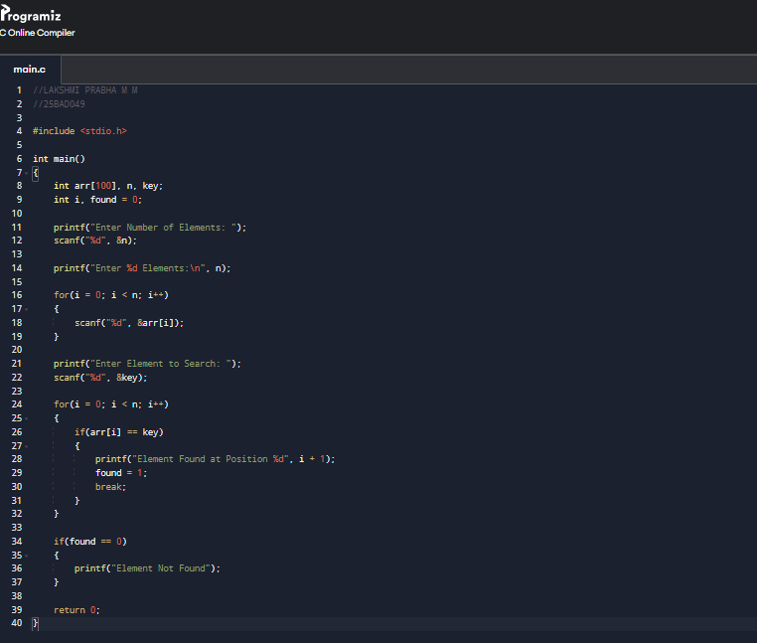

OUTPUT :
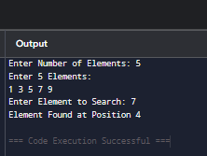

TASK 3: BINARY SEARCH USING ADT
AIM:
To implement the Binary Search algorithm using a sorted array ADT to efficiently search for a given element.

PSEUDO CODE:
START
Read n
For i = 0 to n-1
Read arr[i]
End For
Read key
low = 0
high = n - 1
While low <= high
mid = (low + high) / 2
If arr[mid] == key Then
Print "Element Found at Position", mid + 1
STOP
Else If key < arr[mid] Then
high = mid - 1
Else
low = mid + 1
End If
End While
Print "Element Not Found"
STOP

SOURCE CODE:
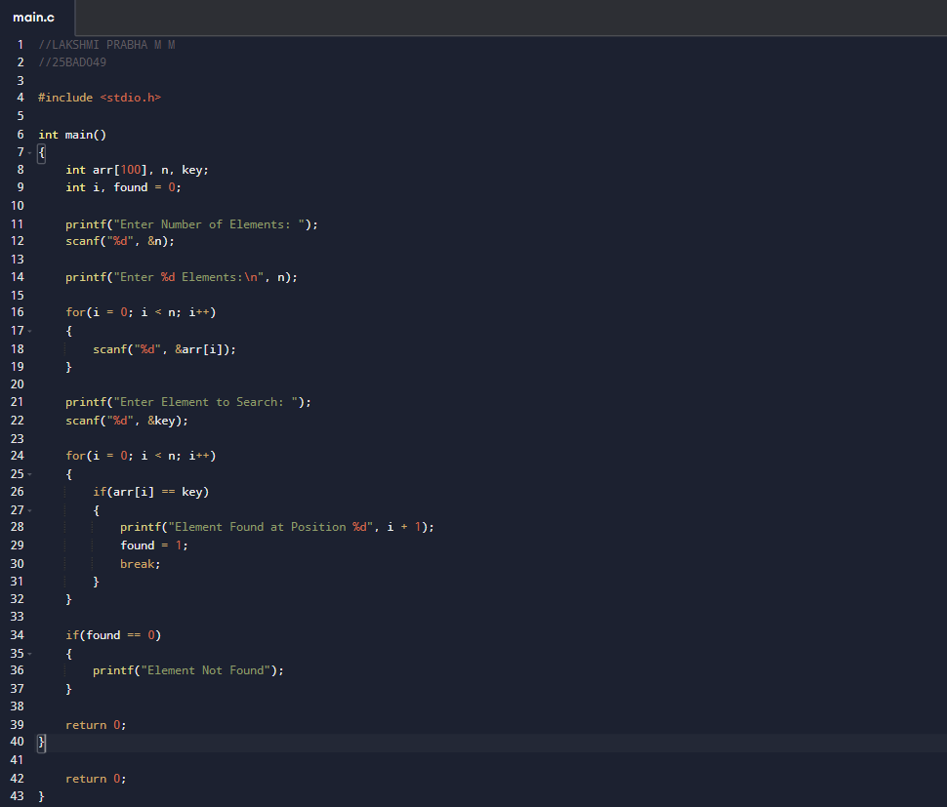

OUTPUT :
